Applicant Information
Name: |  |  | Email:
Phone number: |  |  | Expected Graduation Date:
Please indicate any languages you speak besides English, and your level of fluency (examples: Spanish – native speaker, Tagalog – conversational, Mandarin – beginner):

Internship Information (Requests Made After this Form is Submitted Cannot Be Guaranteed)

Please attach your university’s internship guide or any other Related forms/requirements
University: |  |  | Internship start date: |  | Internship end date:
What degree are you pursuing (MSW, MFT, PCC, PsyD, etc): |  |  | Will this be your first practicum: | Yes No | Internship days  ( (ex: MWF):
Hour Requirements: Hours/days needed per week (ex: 3 days; 5 face-to-face hours, 2 relational hours):
Supervision Requirements: Please indicate the supervision requirements of your university (ex: only MSWs, or those two years past licensure, or with a PPSC, or 6 hours of live supervision):
Other Requirements: Any other requirements or placement type (ex: art therapy, recorded therapy sessions, etc) (Requests made after placement match cannot be guaranteed):
My university allows me to provide services in the community (clients’ homes, etc): |  |  |  |  | Yes No
My university allows me to transport clients:  (Please note if in your car or an agency car): |  |  |  |  | Yes No  If Yes, My car Agency car
I have a car, driver’s license and insurance: Yes No I could drive an agency car if provided one: Yes No
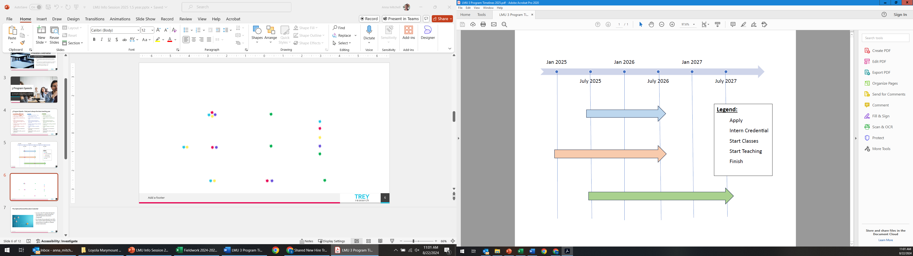

Seneca Family of Agencies Policies
Please initial each box below to indicate that you understand and intend to comply with each of the following Seneca policies for graduate level interns.

Seneca asks that all graduate interns commit to their field placement for at least 9 to 10 months.

All staff and graduate level interns must complete a two week live/synchronous training (Monday through Friday 9:00am to 5:30pm) prior to placement in a program. Most interns complete this training during the summer prior to placement. If you anticipate scheduling conflicts please note them here:

To maintain a safe environment for staff, interns, and clients all staff and interns/trainees are trained on a de-escalation model that may include restraint and seclusion.

Applicant Interests
Placement Setting (Check all that apply. Please note that not all of these settings may be available in your area.)
Adoption and Permanency | School-based | Crisis Support/Diversion
Mental Health | Community-Based | Macro level (no client work)

Which populations are you interested in working with? (Rank your choices: 1= 1st Choice)
___ Infants and Preschool Age | ___ Middle School Age | ___ Transitional Aged Youth (16-25) | ___ Youth on Probation
___ Elementary School Age | ___ High School Age | ___ Family Work-focused | ___ Youth in Foster Care

Geographic location: In which locations are you interested in interning (Rank your choices: 1=1st Choice)
Northern California | Southern California | Central California | Washington State
___ Alameda County  ___ Contra Costa County  ___ Marin County  ___ San Francisco County  ___ San Mateo County  ___ Santa Clara County  ___ Solano County  ___ Sonoma County | ___ Anaheim, CA  ___ Lake Forest, CA  ___ Santa Ana, CA  ___ Ventura County | ___ Monterey County  ___ San Benito County  ___ San Luis Obispo County | ___ Seattle Area  ___ Tacoma Area
Please note that Seneca does not offer remote/virtual clinical internships. Some Macro MSW internships may be remote/ virtual.

How did you hear about Seneca Family of Agencies?

Please expand on your personal and professional goals that you hope to achieve while interning or training at Seneca Family of Agencies:

Additional comments:

Thank you for your interest in Internship at Seneca Family of Agencies
Please attach this form to your cover letter and resume when submitting your online application.
Please note that it may take up to ten business days to hear back from us regarding the status of your application.
If you have any further questions please contact our Internship Coordinator at internship@senecacenter.org.

